**SMART MOTION DETECTING SYSTEM**

BY

|  |  |  |
| --- | --- | --- |
| NAME | CLASS | ROLL NO. |
| Vruti Faria | TE-6 | 06 |
| Rushabh Gada | TE-6 | 07 |
| Vrinda Menon | TE-6 | 16 |

Guide

**Prof. Archana Chaugule**



Department Of Information Technology

**Shah And Anchor Kutchhi Engineering College,Mumbai**

**2018-2019**

|  |  |
| --- | --- |
| **TABLE OF CONTENTS** | **PAGE**  **NO.** |
| Abstract | i |
| List of Figures:  1.1 IOT LEVEL 1  1.2:IOT LEVEL 2  1.3:IOT LEVEL 3  1.4:IOT LEVEL 4  1.5:IOT LEVEL 5  1.6:IOT LEVEL 6  6.1:CIRCUIT DIAGRAM  7.1:Requirements  7.2:Arduino Board  7.3:PIR Front  7.4:PIR Back | ii  2  2  3  3  4  4  9  10  11  12  12 |
| List of Tables | iii |
| Chapter 1: Introduction | 1 |
| Chapter 2: Review of Literature | 5 |
| Chapter 3: Problem Statement | 6 |
| Chapter 4: Objectives | 7 |
| Chapter 5: Project Details/Flow | 8 |
| Chapter 6: Circuit Diagram | 9 |
| Chapter 7:Requirement of Software and Hardware(explain each component) | 10 |
| Chapter 8: Implementation code and Explanation | 12 |
| Chapter 9: Testing (test cases) | 15 |
| Chapter 10: Result | 16 |
| Chapter 11: Conclusion | 17 |
| Chapter 12: References  Appendix:  Reference Papers | 18 |

**CHAPTER 1: INTRODUCTION**

* + The Internet of Things (IOT) is the network of physical devices, vehicles, home appliances, and other items embedded with electronics, software, sensors, actuators, and connectivity which enables these things to connect and exchange data, creating opportunities for more direct integration of the physical world into computer-based systems, resulting in efficiency improvements, economic benefits, and reduced human exertions.
  + IOT involves extending Internet connectivity beyond standard devices, such as desktops, laptops, smartphones and tablets, to any range of traditionally non-internet-enabled physical devices and everyday objects. Embedded with technology, these devices can communicate and interact over the Internet, and they can be remotely monitored and controlled. With the arrival of driverless vehicles, a branch of IOT, i.e. the Internet of Vehicle starts to gain more attention.

**CHARACTERISTICS**

* + - Ambient Intelligence
    - Event-Driven Architecture
    - Complex System
    - Ability to extend as a Real Time System
    - More Extensive Interconnection
    - More Intensive Information Perception
    - More Comprehensive Intelligent Service

1

**LEVELS OF IOT:**

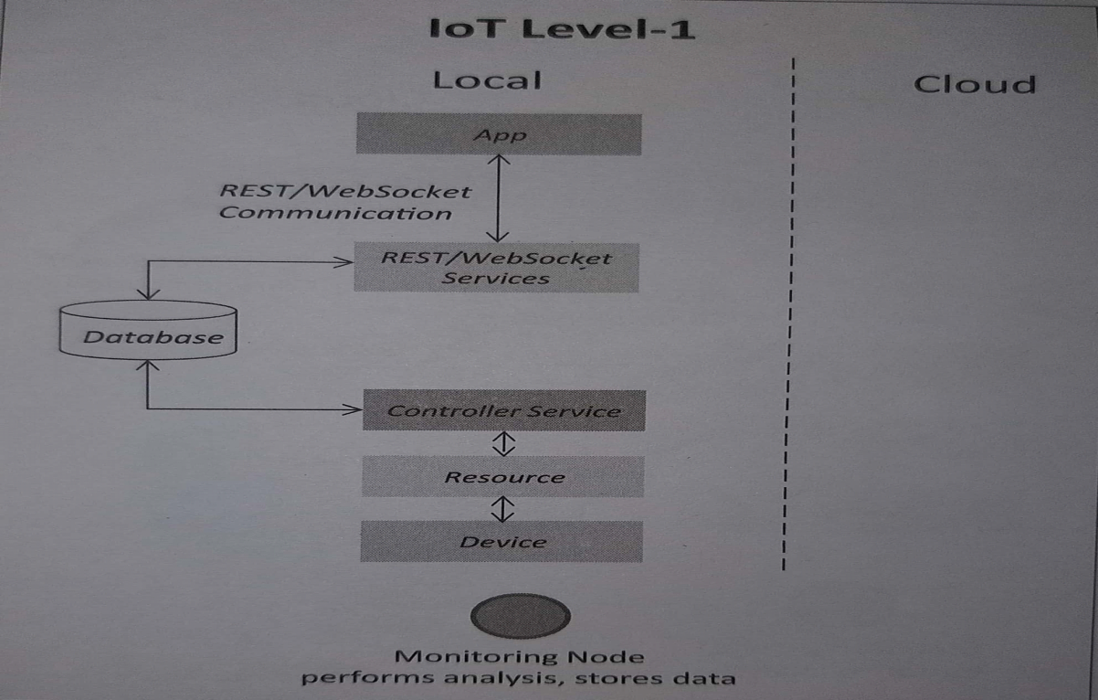

Fig1.1: IOT LEVEL 1

A Level 1 IOT system has a single node that performs sensing and actuation, stores data, performs analysis and hosts the application.it is suitable for modeling low-cost and low complexity solutions where data is not big and analysis requirements are not computationally intensive.

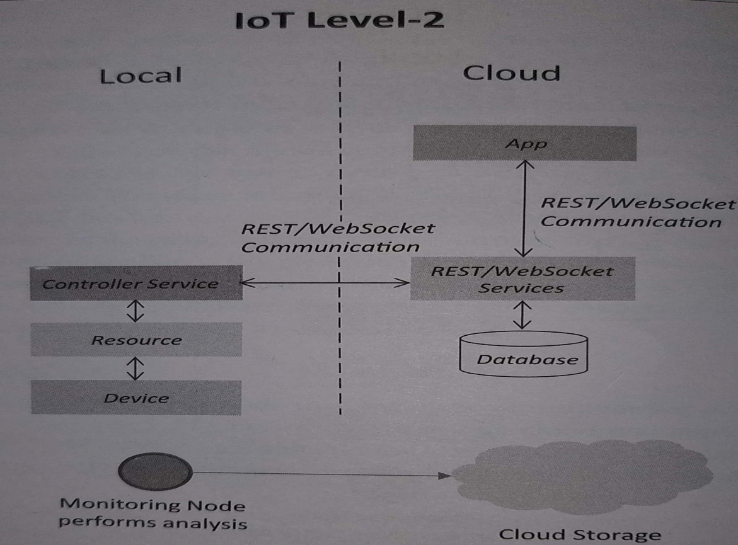

Fig1.2: IOT LEVEL 2

A Level 2 IOT system has a single node that performs sensing and actuation and local analysis. Data is stored in cloud and application is usually cloud-based. Level 2 are suitable for solutions where the data involved is big, however the primary analysis requirement is not computationally intensive and can be done locally.

2

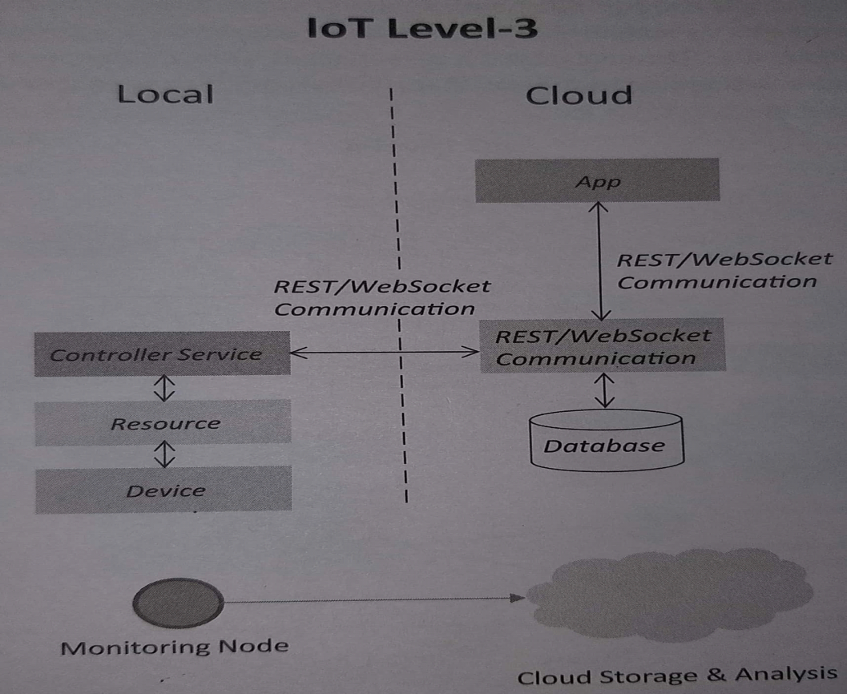

Fig1.3:IOT LEVEL 3

A Level 3 has a single node. Data is stored, and application is cloud-based. Level 3 systems are suitable for solutions where the data involved is big and the analysis requirements are computationally intensive.

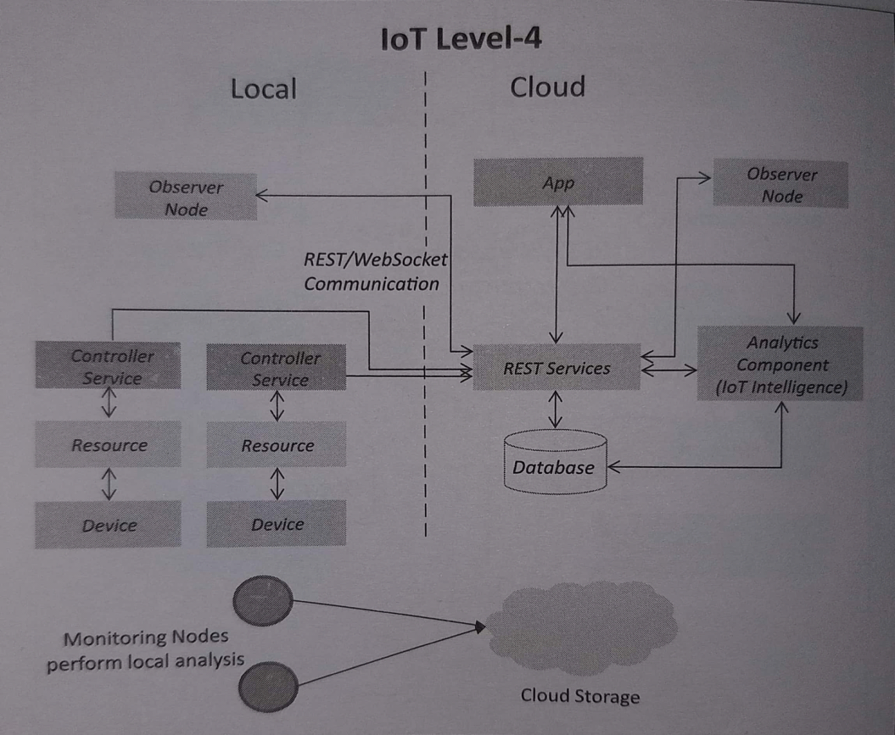

Fig1.4:IOT LEVEL 4

A level 4 system has multiple nodes that perform local analysis. Data is stored in cloud and application is cloud-based. This are suitable for solutions where multiple nodes are required , the data involved is big and the analysis requirements are computationally intensive.

3

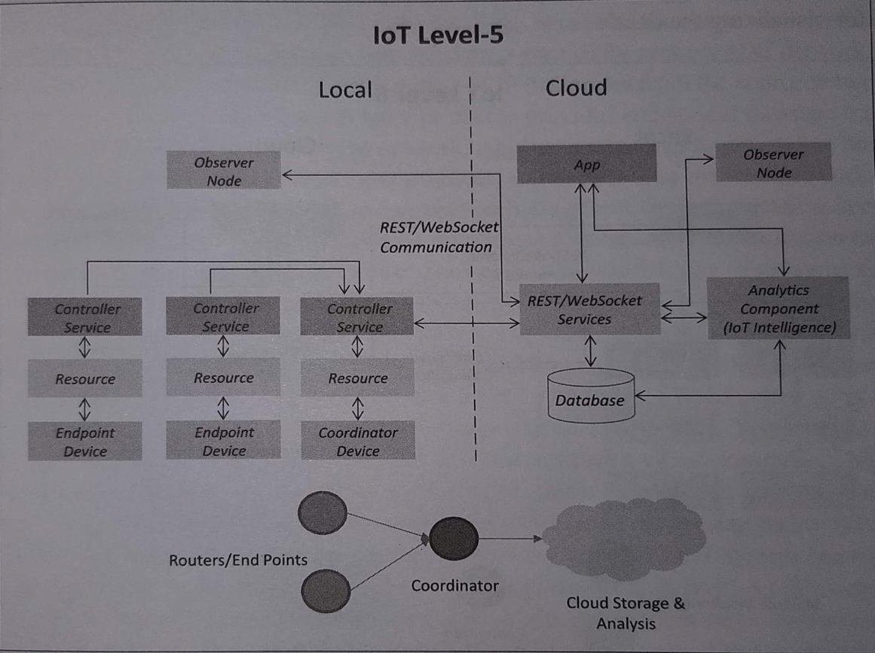

Fig1.5:IOT LEVEL 5

A Level 5 system has multiple end nodes and one coordinator node. Coordinator node collects data from end nodes and sends to cloud.it is suitable for solutions based on wireless sensor networks, in which data involved is big and the analysis requirements are computationally intensive.

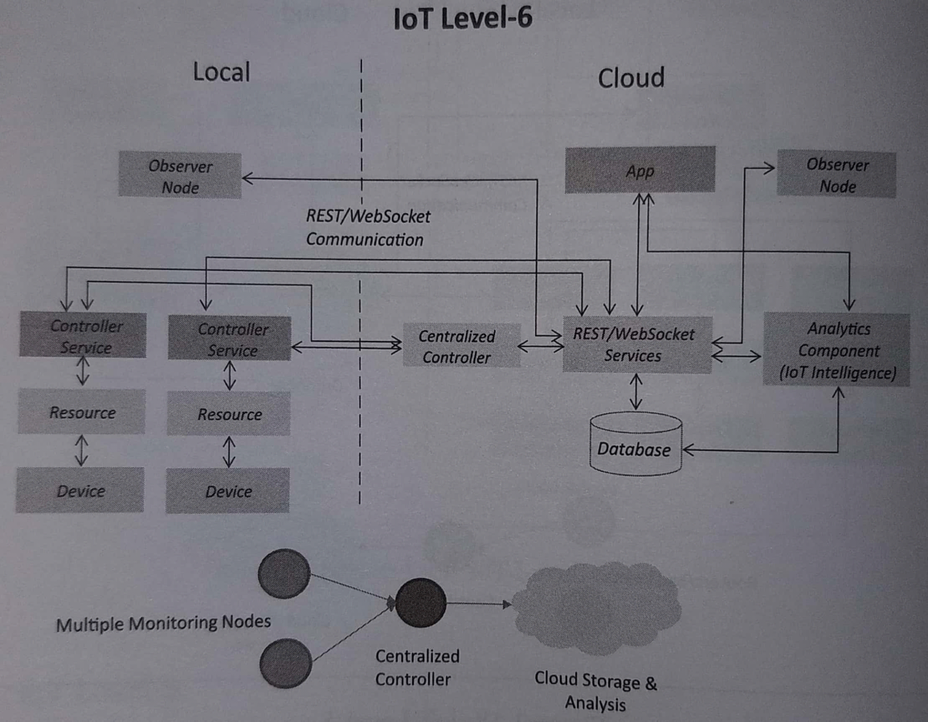

Fig1.6:IOT LEVEL 6

A Level 6 system has multiple independent end nodes that perform sensing and actuation and send data to cloud . Data is stored in cloud and application is cloud-based. The analytics component analyzes the data and stores the results in cloud database. The results are visualized with cloud-based application.

4

**CHAPTER 2: REVIEW OF LITERATURE**

**Advantages of Motion sensor:**

* Following are the advantages of motion sensor of active and passive types:
* It can be used in very harse environment having irregular heat cycles (Active Motion Sensor).
* It has more lifespan which is about 100000 Hrs (Active type).
* It detects motion in light and dark conditions reliably in indoors. (Passive motion sensor)
* It helps in providing security by detecting suspicious movement.
* It is easy to install motion sensors.

**Disadvantages of Motion sensor:**

* Following are the disadvantages of motion sensor of active and passive types:
* Radio frequency at high power is harmful for humans (active type).
* Radio frequency in microwave range do not penetrate metal objects (active type).
* Passive motion sensors do not operate above temperature of 350C.
* Passive sensor type works in LOS (Line of Sight) and does not work in non-LOS regions.
* Passive type is insensitive to very slow motion of the object.
* Passive Infrared (PIR) Sensor can detect human being within approx. 10 meters range.
* Any kind of moving object can trigger the PIR sensor type.

**Increasing Applications:**

* Passive infrared(PIR)
* Microwave
* Ultrasonic
* Tomographic motion detector
* Video Camera Software
* Gesture detector

5

**CHAPTER 3: PROBLEM STATEMENT**

The project we have chosen is a SMART MOTION SENSING SYSTEM.

The aim of this project is to detect moving objects, particularly people.

One common application is activating automatic door openers in businesses and public

buildings.

By using a **BLYNK**  application , we can get notifications` whenever the sensor detects any

motion.

6

**CHAPTER 4: OBJECTIVES**

PIR Motion detector module can detect human movement by detecting infrared emitted by human body.

PIR motion detector module will output a high or low level or open collector signal when it detects human movement. So it is widely used on the motion activated lightening, security system, automatic sensory device and more.

Motion detectors have found wide use in domestic and commercial applications.

In order to get notifications regarding motion detection, the Blynk application sends alerts to the admin/security hub.

**7**

**CHAPTER 5: PROJECT DETAILS**

In this tutorial, we will show you how to create motion activated LEDs which will be triggered by a Parallax PIR sensor and controlled by an Arduino Uno. This project can have practical applications such as night lighting for stairs, walkways, etc.

The 4 LEDs are attached to Digital Output PWM pins 5,6,9 and 10. Each has a resistor before the LED to reduce the current stress. They all share a common ground at the very top of the breadboard (from perspective of the figure).  
  
 The Parallax PIR Motion Sensor, GND shares the same common ground as the LEDs, Vcc is connected to the Arduino's 5V output, and OUT is connected to digital pin 12 on the Arduino.Power this project with your  9VDC 650mA  wall adapter power supply.

8

**CHAPTER 6: CIRCUIT DIAGRAM**

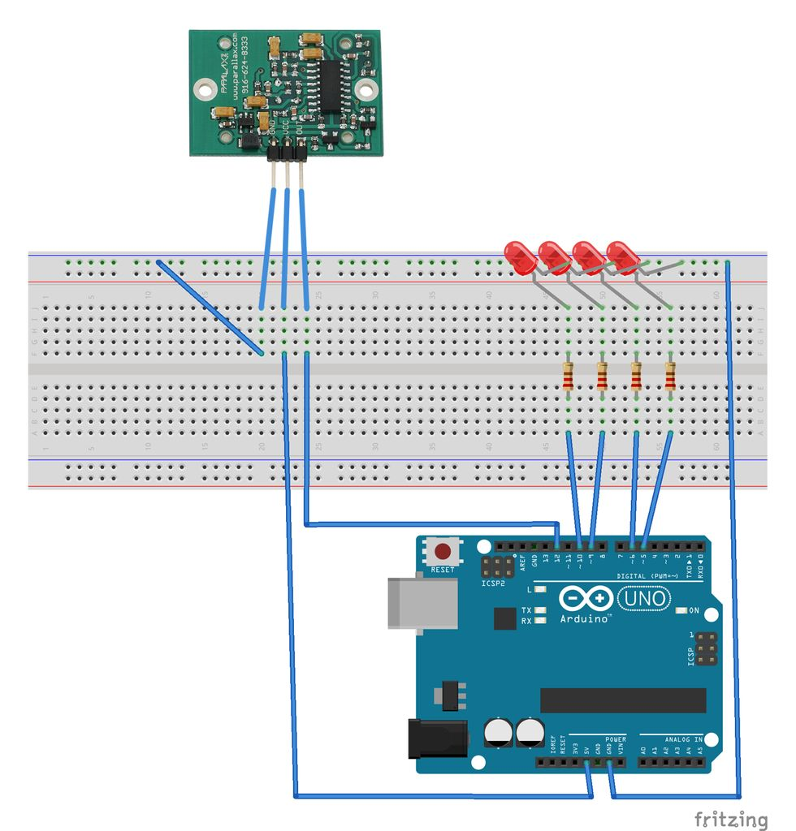

Fig 6.1:Circuit Diagram

The 4 LEDs are attached to Digital Output PWM pins 5,6,9 and 10. Each has a resistor before the LED to reduce the current stress. They all share a common ground at the very top of the breadboard (from perspective of the figure).  
  
 The Parallax PIR Motion Sensor, GND shares the same common ground as the LEDs, Vcc is connected to the Arduino's 5V output, and OUT is connected to digital pin 12 on the Arduino.Power this project with your  9VDC 650mA  wall adapter power supply.

Also , after all these connections we connect this project with BLYNK APPLICATION which is available on the Android Playstore , using BLYNK libraries.

This connection is done by connecting the mobilephone to the computer using USB serial cable.

**9**

**CHAPTER 7: REQUIREMENT OF Software and Hardware**

**Materials:**

For this project we will need:  
  
 1. Arduino Uno  
 2. Parallax PIR Motion Sensor  
 3. [Mini Breadboard](https://www.sparkfun.com/products/137)  
 4. [USB A to B cable](https://www.sparkfun.com/products/512)  
 5. [4x LEDs](https://www.sparkfun.com/products/531)   
 6. [4x 220ohm resistors](http://www.radioshack.com/product/index.jsp?productId=2062340)   
 7. [Solid Core Wire](https://www.sparkfun.com/products/8023)   
 8. [Wall Adapter Power Supply - 9VDC 650mA](https://www.sparkfun.com/products/298)

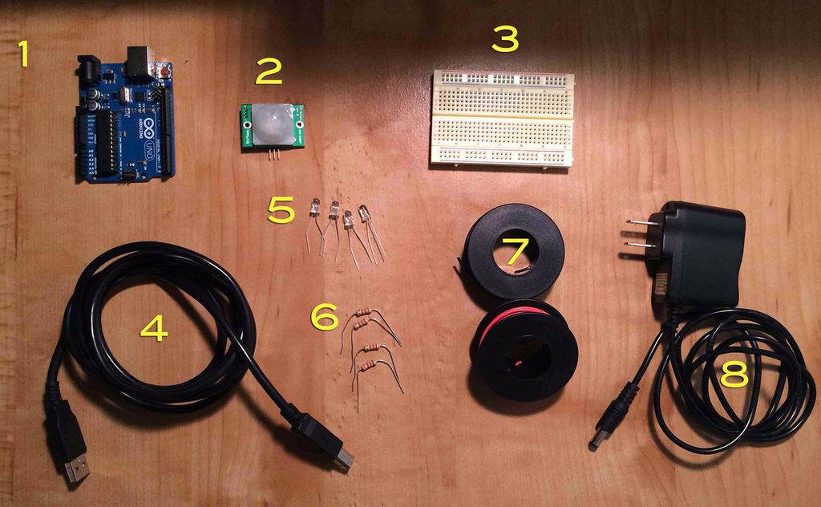

Fig7.1: Requirements

Arduino: Arduino is an open-source physical computing platform based on a simple i/o board and a development environment that implements the processing language

10

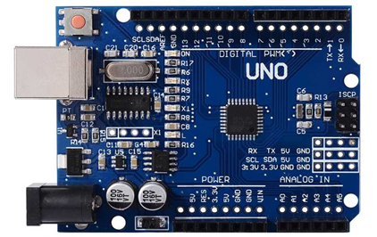

Fig 7.2:Arduino Board

PIR sensor: The PIR Sensor detects motion by measuring changes in the infrared (heat) levels emitted by surrounding objects. When motion is detected the PIR sensor outputs a high signal on its output pin.

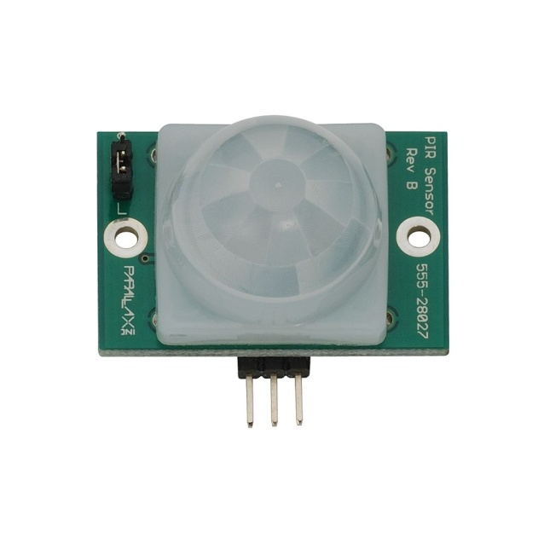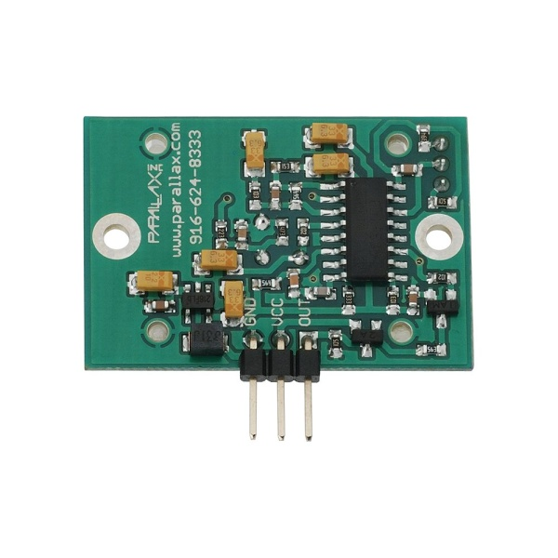

**Fig7.3:PIR Front Fig7.4:PIR Back**

**Key Features:**  
  
Detection range up to 15 ft. away on short setting, up to 30 ft. away on long setting   
Onboard LEDs light up the lens for fast visual feedback when movement is detected   
Mounting holes for 2-56 sized screws provide easy integration in permanent applications   
3-pin SIP package perfect for breadboard-friendly projects.

11

**CHAPTER 8: IMPLEMENTATION**

int LEDArray[] = {5, 6, 9, 10}; // LED array for PWM 5,6,9 and 10

int numOfLEDs = 4; // LEDs of index 0-3

int pirState = LOW;

int pirVal = 0;

int pirPin = 12;

/* Comment this out to disable prints and save space */

#define BLYNK_PRINT DebugSerial

// You could use a spare Hardware Serial on boards that have it (like Mega)

#include <SoftwareSerial.h>

SoftwareSerial DebugSerial(0, 1); // RX, TX

#include <BlynkSimpleStream.h>

// You should get Auth Token in the Blynk App.

// Go to the Project Settings (nut icon).

char auth[] = "ca7ea89d5cc440cda6d5ba5f794c5fdb";

void setup()

{

12

// Debug console

DebugSerial.begin(9600);

// Blynk will work through Serial

// Do not read or write this serial manually in your sketch

Serial.begin(9600);

Blynk.begin(Serial, auth);

pinMode(pirPin, INPUT);

int i;

for(i = 0; i < numOfLEDs; i++) {

pinMode(LEDArray[i], OUTPUT);

}

}

void loop()

{

Blynk.run();

pirVal = digitalRead(pirPin);

int i;

//if motion is captured, light the LEDs in sequen

if (pirVal == HIGH) {

Blynk.notify("motion detected");

for (i= 0; i < numOfLEDs; i++) {

analogWrite(LEDArray[i], 255);

delay (1000);}

13

\

delay (1000);

for (i= 0; i < numOfLEDs; i++) {

analogWrite(LEDArray[i], 0);

delay (1000);

}

if (pirState == LOW) {

pirState = HIGH;

}

}

//else, set all LED values to zero

else {

analogWrite(LEDArray[0], 0);

analogWrite(LEDArray[1], 0);

analogWrite(LEDArray[2], 0);

analogWrite(LEDArray[3], 0);

if (pirState == HIGH) {

pirState = LOW;

}

}

}

14

**CHAPTER 9: TESTING**

After all the connections are complete along with the BLYNK APP connections, the sensor responded and there was a push notification, giving a pop up “MOTION DETECTED” .

As soon as our project goes offline, we also get a pop up saying “Your project went offline .”

15

**CHAPTER 10: RESULT**

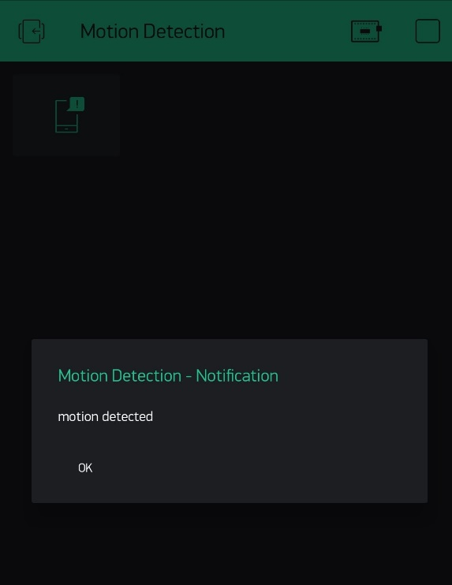 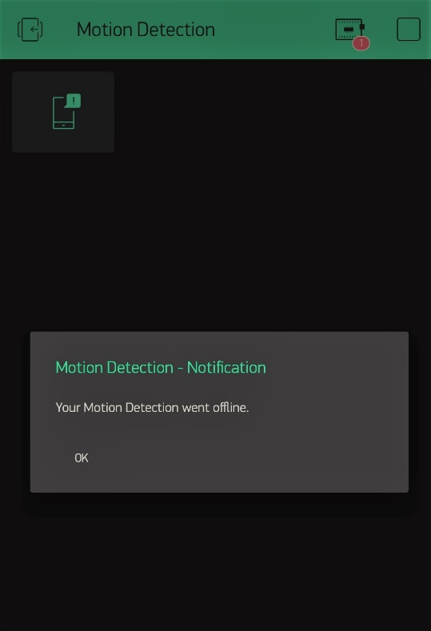

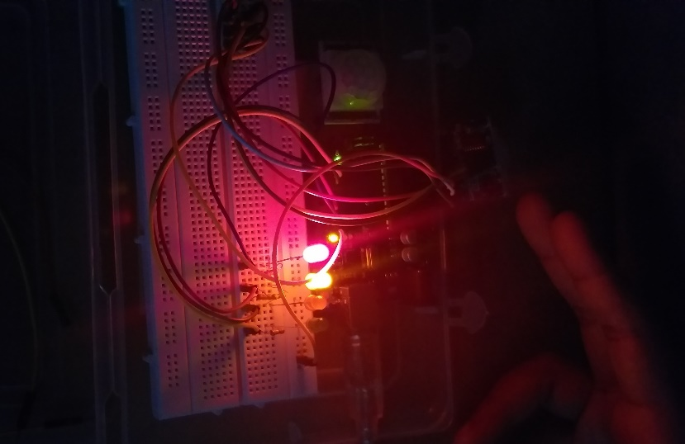

16

**CHAPTER 11: CONCLUSION**

* In this project, a simple Motion Sensing system using a PIR sensor is implemented using Arduino UNO development board. Although it is not the practical implementation for real life scenarios, it gives a general idea of the process behind the motion sensing system
* Blynk is a Platform with iOS and Android apps to control Arduino, Raspberry Pi and the likes over the Internet.
* It's a digital dashboard where you can build a graphic interface for your project by simply dragging and dropping widgets.
* Using a BLYNK application we can get notified if any movement is sensed by the PIR sensor.

17

**CHAPTER 12: REFERENCES**

[https://www.instructables.com/id/Motion Activated LEDs/](https://www.instructables.com/id/Motion%20Activated%20LEDs/)

[https://ieeexplore.ieee.org/document/7009229/](https://www.google.com/url?sa=t&rct=j&q=&esrc=s&source=web&cd=1&cad=rja&uact=8&ved=2ahUKEwjN--aBiqbeAhUszoUKHXOfCyUQFjAAegQICRAB&url=https%3A%2F%2Fieeexplore.ieee.org%2Fdocument%2F7009229%2F&usg=AOvVaw1T4lW1Pd-P8TKyCVqdFZix)

[https://ieeexplore.ieee.org/document/7754788/](https://www.google.com/url?sa=t&rct=j&q=&esrc=s&source=web&cd=3&ved=2ahUKEwij2Ia2iqbeAhVG-YUKHQbTAyYQFjACegQICBAB&url=https%3A%2F%2Fieeexplore.ieee.org%2Fdocument%2F7754788%2F&usg=AOvVaw3Qu4vjioMTQC_dmVH5qMGk)

[https://ieeexplore.ieee.org/document/7556055/](https://www.google.com/url?sa=t&rct=j&q=&esrc=s&source=web&cd=6&ved=2ahUKEwij2Ia2iqbeAhVG-YUKHQbTAyYQFjAFegQIBRAB&url=https%3A%2F%2Fieeexplore.ieee.org%2Fdocument%2F7556055%2F&usg=AOvVaw0HCkPCSpoYO3d_1r8-i767)

18

**Approval for Project Report for Third Year Semester V**

**IOT Lab**

This project report entitled **SMART MOTION DETECTING SYSTEM USING ARDUINO** by **VRUTI FARIA, RUSHABH GADA** and **VRINDA MENON** is approved in partial fulfilment of the requirement for the IOT Lab of Third Year Engineering

Examiners:

1._________________

2._________________

3._________________

Guide:

1._________________